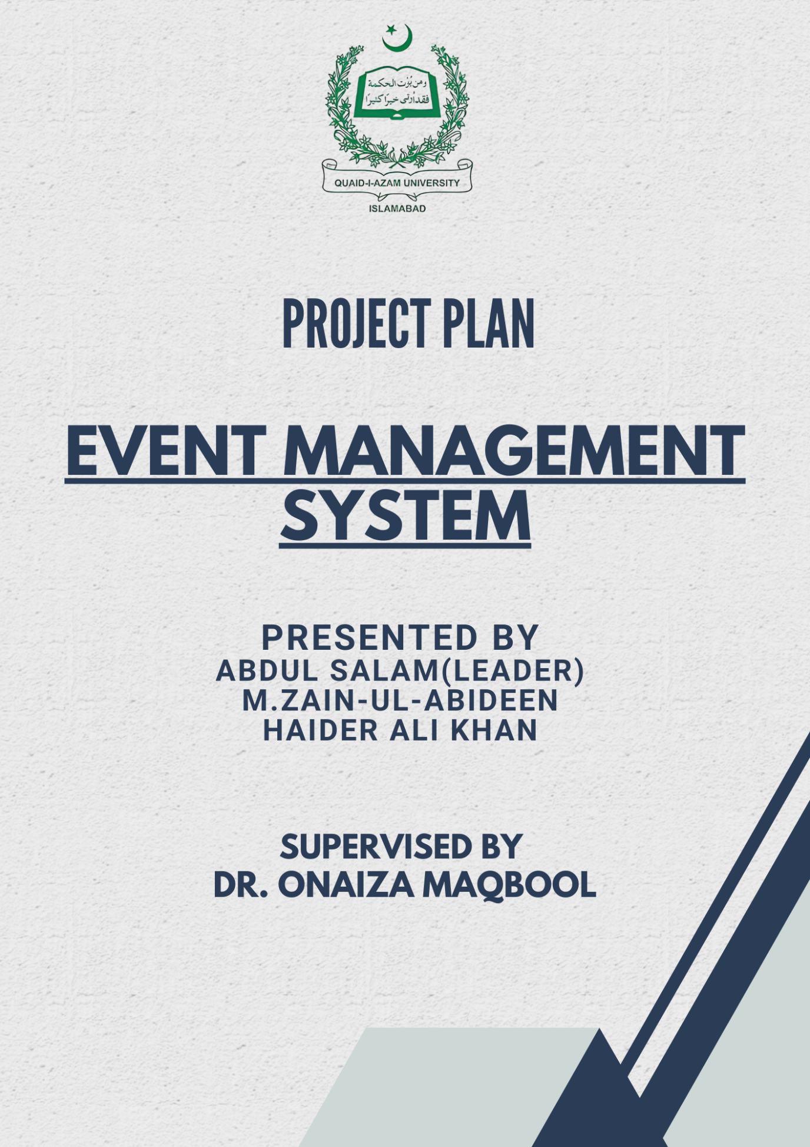

**PROJECT PLAN DOCUMENT APPROVAL SIGNATURES**

**Member 1(Leader)**

**_______________ _______________ _______________** Name Signature Date

**Member 2**

**_______________ _______________ _______________** Name Signature Date

**Member 3**

**_______________ _______________ _______________** Name Signature Date

**Stakeholders**

**_______________ _______________**  Signature Date

**Supervisor**

**_______________ _______________ _______________** Name Signature Date

**Change History**

|  |  |  |  |
| --- | --- | --- | --- |
| Version | Date | Changed by | Description |
|  |  |  |  |
|  |  |  |  |
|  |  |  |  |
|  |  |  |  |
|  |  |  |  |
|  |  |  |  |

**Remarks**

**_____________________________________________________________**

**____________________________________________________________________________________________________________________________________________________________________________________________________________________________________________________**

**________________**

Signature

**DR. ONAIZA MAQBOOL** Professor, QAU Islamabad

**Table of Contents**

1. Project Overview 5

1.1 Project Summary 5

1.2 Purpose, Scope, and Objectives 5

1.3 Assumptions and Constraints 6

1.4 Project Deliverables 6

1.5 Schedule Summary 7

2. References 7

3. Definitions 7

4. Project Context 7

4.1 Process Model 7

4.2 Methods, Tools, and Techniques 8

4.3 Product Acceptance Plan 8

5. Project Planning 9

5.1 Project Work Plan 9

5.2 Work Activities 9

5.3 Schedule Allocation 10

5.4 Resource Allocation 11

8. Supporting Process Plans 12

8.1 Risk Management 12

Task Division 12

# 1. Project Overview

## 1.1 Project Summary

The main aim of this project is to develop a system that allows the department to manage and track various events (e.g., seminars, competitions) that students can participate in. The system will allow the department to:

* Announce events.
* Set event requirements.
* Manage student registrations.
* Provide post-event updates (e.g., news, pictures).
* Enable attendees to rate events.

## 1.2 Purpose, Scope, and Objectives

**Purpose:**

* To create a centralized platform for the department to manage events, track student participation, and allow post-event feedback and updates as such a system doesn’t currently exist in our current department.

**Scope:**

* **Context:** Desktop based system for managing event announcements, registrations, and post-event activities.
* **Functions:**
  + Allow the department to announce events (internal or external).
  + Set event requirements (e.g., eligibility, maximum participants).
  + Allow students to register for events.
  + Upload post-event updates (news, pictures).
  + Allow teachers and students to rate events.

**Objectives:**

* Provide a centralized platform for event management.
* Streamline the process of event announcements, registrations, and post-event updates.
* Enable feedback attendees through event ratings.

## 1.3 Assumptions and Constraints

**Assumptions:**

* The department will provide accurate event details and requirements.
* Attendees will use the system to register and rate events.
* The system will be used only by the department and its students.
* Another department may register If they want to join the event.

**Constraints:**

* The system will be a **desktop platform**.
* The project must be completed within **this semester**.
* The system will be available only in **English**.
* The software will be built using **Java programming language.**

## 1.4 Project Deliverables

* **Documents:**
  + Project Plan
  + Software Requirements Specification (SRS)
  + Analysis Document
  + Design Document
* **Fully Functional Software:**
  + Event announcement and management system.
  + Student registration module.
  + Post-event updates and rating system.
* **Testing Reports:**
  + Quality assurance and testing reports.
* **User Guidelines:**
  + System manuals to assist users in navigating the software.

## 1.5 Schedule Summary

* **Phase 1 (Planning):** 1 week
* **Phase 2 (Analysis):** 3 weeks
* **Phase 3 (Design):** 4 weeks
* **Phase 4 (Development):** 4 weeks
* **Phase 5 (Testing):** 1 week

# 2. References

1. IEEE Software Construction Guideline. ISO/IEC/IEEE 16326:2019(E)
2. Project Libre manual version 0.1-October 6, 2012.

# 3. Definitions

* **Event:** Any activity organized by the department or external organizations.
* **Registration:** The process by which students sign up to participate in an event.
* **Post-Event Updates:** Any type of information uploaded after an event.
* **Rating:** Feedback provided by teachers and students about the event.

# 4. Project Context

## 4.1 Process Model

The project will adopt a **Waterfall process model** to ensure a structured and sequential development approach. The Waterfall model will allow for clear documentation, well-defined phases, and a systematic progression through requirements gathering, design, implementation, testing, deployment, and maintenance.

**Key Features to be Developed in Phases:**

1. Event announcement module.
2. Event requirements and registration module.
3. Event rating module.

## 4.2 Methods, Tools, and Techniques

**Methods:**

* **Waterfall Methodology:** For managing development through a sequential process.
* **Object-Oriented Programming (OOP):** For managing software architecture.

**Tools:**

* **Java:** Programming language.
* **IntelliJ Idea:** Code editor.
* **MySQL:** Database management for storing event details, registrations, and ratings.
* **Figma:** For designing the user interface.
* **Git/GitHub:** For version control.

**Techniques:**

* Regular stakeholder meetings to gather requirements and feedback.
* Weekly team meetings to track progress and resolve blockers.

## 4.3 Product Acceptance Plan

**Acceptance Criteria:**

1. **Event Announcement:**
   * The department should be able to create, modify, and delete event announcements.
   * Events should have clear requirements (e.g., eligibility, maximum participants).
2. **Student Registration:**
   * Students should be able to register for events.
   * The system should confirm successful registration and notify students.
3. **Post-Event Updates:**
   * The department should be able to upload news, pictures, or other updates after the event.
4. **Event Ratings:**
   * Teachers and students should be able to rate events.
   * The system should calculate and display average ratings.

# 5. Project Planning

## 5.1 Project Work Plan

The project will follow the **Scrum model** with clearly defined sprints. Each sprint will include planning, analysis, design, development, and testing phases.

**Key Phases:**

1. **Planning:** Define project scope, objectives, and timelines.
2. **Analysis:** Gather requirements for event management, registration, and ratings.
3. **Design:** Create prototypes and architectural designs for the system.
4. **Development:** Implement the event announcement, registration, and rating modules.
5. **Testing:** Test the system for functionality, usability, and performance.

## 5.2 Work Activities

* **Sprint 1:** Event announcement module.
* **Sprint 2:** Event requirements and registration module.
* **Sprint 3:** Post-event updates module.
* **Sprint 4:** Event rating module.

## 5.3 Schedule Allocation

* 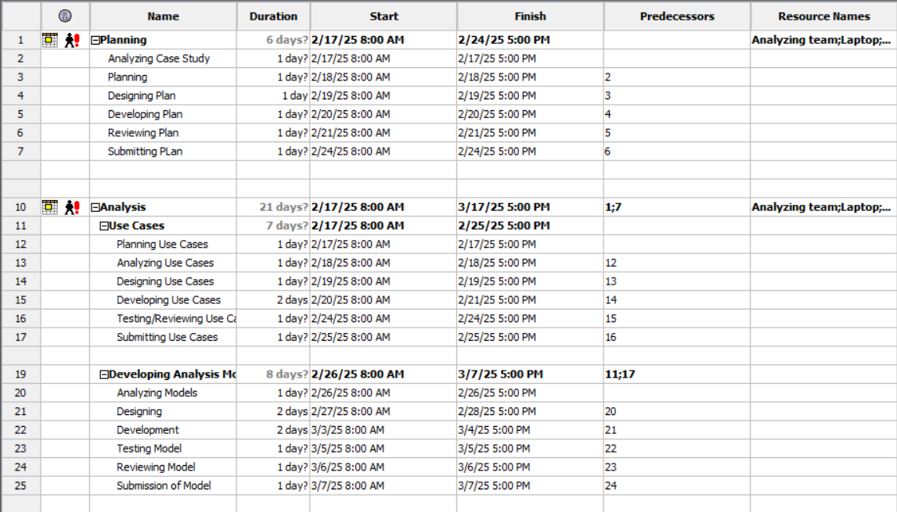**Gantt Chart**

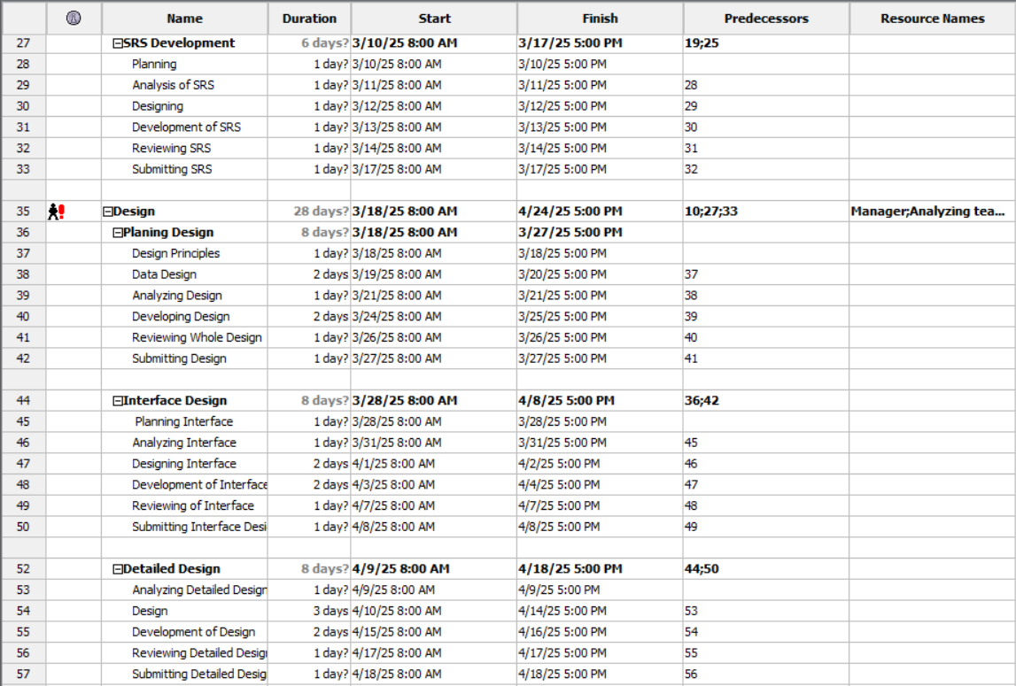

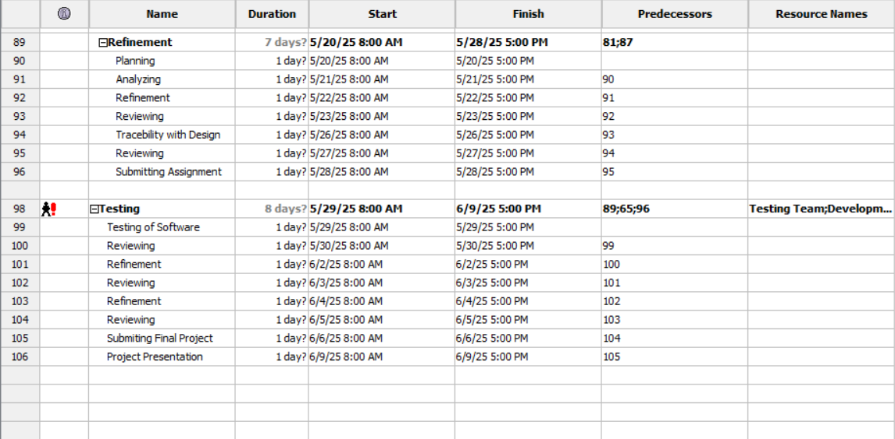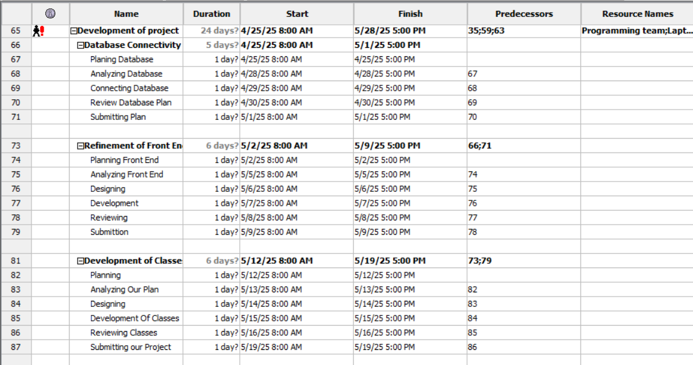

## 5.4 Resource Allocation

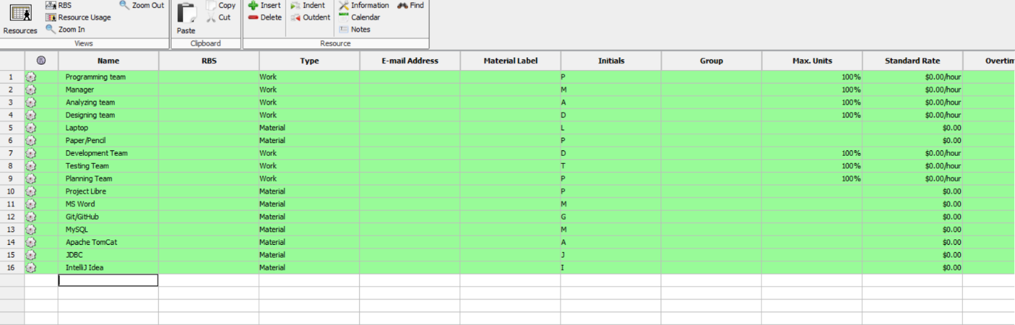

# 8. Supporting Process Plans

## 8.1 Risk Management

**Risk Identification:**

* **Technological Risks:** Issues with integrating Java, MySQL, or other tools.
* **Scheduling Risks:** Delays in development or testing phases.
* **Personnel Risks:** Unavailability of team members.

**Risk Mitigation:**

* Regular code reviews and testing.
* Cross-training team members to cover multiple roles.
* Using Project Libre to track milestones and reallocate resources if needed.

# Task Division

**Abdul Salam**: Section1 – 3 (Team lead)

**Haider Ali Khan**: Section 4 & 8

**M Zain-ul-Abideen**: Section 5